**UNIVERSITY OF AGRICULTUE, FAISALABAD**

**Department of Irrigation and Drainage**

**Faculty of Agricultural Engineering and Technology**

**Synopsis for M.Sc. (Hons.) Agricultural Engineering**

**TITLE: ASSESSMENT OF WATER USE EFFICIENCY OF MAJOR CROPS USING GEOSPATIAL TECHNIQUES UNDER ARID CLIMATE**

Name of Student Engr. Muhammad Sohail

Registration No. 2019-ag-8961

**Abstract**

The Indus Basin is a critical agricultural region in South Asia, which faces significant challenges due to climate change and water scarcity. The study's objective is to compute the ET and analyze the spatiotemporal variability of water use efficiency (WUE) of wheat, sugarcane, and maize in the region of Rahim Yar Khan (arid) in the Indus Basin. The SEBAL model, implemented in Google Earth Engine (GEE), will be used to estimate ET from Landsat imagery over a 10–20-year period (2005–2025). Crop yield data will be obtained from the Agriculture Department of Punjab, and WUE will be calculated as the crop yield ratio to ET. Fieldwork will be conducted over one year to collect ground truthing points for validation. The study will analyze trends in ET and WUE, identify factors influencing these metrics, and provide insights into sustainable water management practices. The findings will contribute to optimizing water use in agriculture, enhancing crop productivity, and informing policy decisions in the face of climate change. This research is particularly significant for improving water resource management and ensuring food security in the Indus Basin.

**Keywords:** Evapotranspiration, SEBAL Model, Google Earth Engine, Landsat Imagery, Climate Change, Rahim Yar Khan.

**UNIVERSITY OF AGRICULTUE, FAISALABAD**

**Department of Irrigation and Drainage**

**Faculty of Agricultural Engineering and Technology**

**Synopsis for M.Sc. (Hons.) Agricultural Engineering**

1. **TITLE:** **ASSESSMENT OF WATER USE EFFICIENCY OF MAJOR CROPS USING GEOSPATIAL TECHNIQUES UNDER ARID CLIMATE**

**II. a) Date of Admission** 18-09-2023

1. Date of Initiation 14-09-2024
2. Probable Duration 6 Months

**III. PERSONNEL**

1. Name of the Student Engr. Muhammad Sohail
2. Registration Number 2019-ag-8961

**IV. SUPERVISORY COMMITTEE**

1. Supervisor Dr. Muhammad Zaman

([muhammad.zaman@uaf.edu.pk](mailto:muhammad.zaman@uaf.edu.pk))

1. Member Dr. Kashif Mehmood

([kashifmehmood@uaf.edu.pk](mailto:kashifmehmood@uaf.edu.pk))

1. Member Dr. Iftikhar Ali

([dr.iftikharali@uaf.edu.pk](mailto:dr.iftikharali@uaf.edu.pk))

**V.** **Introduction**

The Indus River Basin serves as a vital water resource for more than 268 million individuals, which is increasingly threatened by the impacts of climate change, necessitating stronger and more coordinated regional water management strategies (Rollason *et al.*, 2023). The Indus Basin is among the regions globally confronting significant challenges in its water sector. (Khero et al., 2020). These issues stem from population growth, rapid growth of urbanization and industrialization, environmental degradation, unregulated resource exploitation, inefficient water usage, and poverty, all of which are further made stronger by the effects of climate change (Laghari *et al.*, 2012).

Evapotranspiration plays a vital role in the water cycle & is a fundamental component of balancing the energy on the surface of the Earth (Kumar, 2024). It consists of two interconnected processes such as evaporation which comes from soil and transpiration which comes from plants contribute to water loss. These approaches are challenging to distinguish individually because they often occur at the same time, with varying rates and significant spatial variability (Allen *et al.*, 2007).

Conventional methods for measuring evapotranspiration (ET), such as soil water balance, the Bowen ratio, and the Eddy flux approach, are primarily designed for field-scale applications. However, they are inadequate in their ability to compute ET fluxes over higher spatial levels due to the natural variability of land surfaces and the complex, vigorous behavior of water vapor conveyance procedures (Gao *et al.*, 2008). The SEBAL is a model that utilizes geospatial technology to calculate evapotranspiration (ET) and surface energy fluxes (Bastiaanssen *et al.*, 2005).

Water use efficiency is the ratio of carbon assimilated into grain to the amount of water consumed by a crop, which is a critical factor in ensuring agricultural sustainability, especially in climate change. WUE is significantly impacted by various factors such as rising temperatures, changing precipitation patterns, and enhancing the levels of atmospheric CO2, creating sophisticated interactions at both the leaf and canopy levels (Hatfield and Dold, 2019). Water use efficiency (WUE) in Pakistan's agricultural sector is a pressing issue, particularly as water resources continue to decline. Research indicates significant potential for improving irrigation practices across different crops. For instance, in sugarcane farming, although technical efficiency is relatively high, there remains a substantial opportunity to optimize the efficiency of irrigation water use (Ul-Allah *et al.*, 2015).

The deficiency of effective irrigation approaches and policy recommendations in Pakistan presents a serious risk to the country's water and food security (Bukhari *et al.*, 2024). With water scarcity becoming an increasingly pressing issue, the need to manage irrigation under constrained water conditions will become a standard practice rather than an occasional challenge (Jabeen *et al.*, 2021). Globally, agriculture consumes 80–90% of the freshwater human’s use, with the majority allocated to crop production (Morison *et al.*, 2008). In numerous regions, this level of water usage is unsustainable. Additionally, water resources face growing pressure from competing demands and are increasingly impacted by the effects of climate change (Morison *et al.*, 2008).

**Problem Statement**

The lack of precise ET estimates and comprehensive studies on water use efficiency (WUE) for major crops in the basin present challenges for policymakers and farmers. Addressing these challenges is essential for optimizing water resource management and improving crop productivity. This study's purpose is to compute the evapotranspiration and actual water use in Rahim Yar Khan to analyze the spatiotemporal variability of WUE for major crops. The findings will provide insights into sustainable water management practices under changing climatic conditions.

**Objectives**

1. To estimate the evapotranspiration and actual water use for Rahim Yar Khan District.
2. To analyze the spatiotemporal variability of water use efficiency for major crops in the area.
3. **Review of Literature**

Allen *et al.* (2001) concluded that the SEBAL is a geospatial model designed to estimate evapotranspiration (ET) across large areas, requiring minimal weather data. The Surface Energy Balance Algorithm for the Land was used to estimate ET using the data of Landsat Satellite Imagery in the Basin of Bear River in southeastern Idaho, United States of America. The results were then compared to ground-based measurements, showing strong agreement. This demonstrates that SEBAL is a reliable and effective tool for quantifying ET at a field-specific level, making it valuable for supporting the rights of water management and ensuring adherence to water agreements among multistate.

Qureshi (2011) explored that the Indus River Basin is the lifeblood of the agricultural sector of Pakistan, supporting the largest irrigation system in the globe and giving water for ninety percent food production of the country. In turn, Agriculture contributes twenty-five percent of the GDP of Pakistan, underscoring its critical role in the national economy. However, Pakistan faces an impending water crisis that threatens its food security. By 2025, the country is projected to experience a thirty-two percent shortfall in water requirements, potentially prominent to a food shortage of seventy million tons. This challenge is made worse by the prediction that by 2025, surface water storage capacity will have decreased by 30% due to climate change and the siltation of large reservoirs. The capacity of Pakistan to sustain irrigated agriculture is in threat condition due to decreasing its per capita capacity of water storage which is only 150 m³ far below that of the United States (5000 m³), Australia (5000 m³), and China (2200 m³). Declining surface water supplies and over-extraction of groundwater further exacerbate the situation, posing serious threats to agricultural productivity. Traditional supply-side solutions, such as increasing water availability, are no longer viable. Instead, Pakistan must focus on enhancing water-use efficiency, expanding storage capacity, and managing the resources of surface and groundwater sustainably to combat issues like soil salinization and waterlogging. Additionally, enhancing individual and institutional capacity, as well as fostering collaboration among organizations, will be critical to supporting irrigated agriculture in the Indus Basin. This study highlights the urgent need for strategic investments and reforms to unlock the immense potential for improving agricultural productivity and ensuring long-term food and water security in Pakistan.

Bala *et al.* (2016) focused on Evapotranspiration (ET), an essential procedure in the land-atmosphere study, utilizing the SEBAL to assess ET on multiple dates in early 2011 using LANDSAT7-ETM+ data. The research was conducted at the Institutes of an Indian Agricultural Research and Agricultural Farm and involved validating SEBAL's Evapotranspiration estimation against Lysimeter data, which provides ground-based measurements.

Rehman (2016) analyzed and reviewed Pakistan's economic and agricultural development during 2013, 2014, and 2015, while drawing comparisons with other key economies such as China, India, Japan, Russia, and Bangladesh. Agriculture remains the cornerstone of Pakistan's economy, serving as the largest sector and a critical driver of growth and poverty alleviation. Contributing approximately 26% to the GDP of the country and engaging over 46% of the laborious force, agriculture plays a crucial role in the production, processing, and distribution of essential commodities. Key agricultural products, including cotton, sugar, wheat, edible oil, milk, and meat, not only sustain rural livelihoods but also serve as a primary source of income for 68% of the population. Furthermore, agriculture fuels industrial growth by supplying raw materials and generates significant foreign exchange earnings through exports. This study aims to highlight the sector's contributions to economic development, assess its performance during the specified period, and provide a comparative analysis with other nations to identify opportunities for sustainable growth and improved agricultural practices.

Jaafar and Ahmad (2020) described that Lebanon's Bekaa Valley, home to the world's highest refugee population per capita and a key agricultural region, faces severe groundwater depletion, with levels dropping over 15 meters in five years. Using Landsat imagery and two energy balance models (METRIC and pySEBAL), this study estimated field-scale evapotranspiration (ET) from 1984 to 2017, averaging 652 ± 53 mm annually. Most ET (64%) occurs in the dry season, heavily relying on groundwater, which is depleting at 330 ± 50 mm/year. The findings highlight the urgent need for sustainable water management to support agriculture and improve resilience for refugees and local communities.

Muzammil *et al.* (2020) concluded that Pakistan's agriculture relies on the Indus Basin, facing severe water scarcity due to poor irrigation and weak policies. A water footprint (1997–2016) study of Punjab and Sindh shows that 75% of water comes from irrigation, with sugarcane, cotton, and rice consuming 57%. Optimized cropping and advanced irrigation could cut water use by 50%, highlighting the need for sustainable policies.

Jabeen *et al.* (2021) concluded that the absence of effective irrigation applications and policy recommendations in Pakistan poses significant challenges to the water and food security of the nation. With water scarcity becoming increasingly prevalent, the future of irrigation will depend on precise water management strategies to optimize agricultural productivity. This research investigates the effect of limited irrigation practices on the grain yield of wheat and water use efficiency in Pakistan’s arid and semi-arid regions. Using the DSSAT model, the research simulated wheat yield and evaluated alternative irrigation scheduling strategies, ranging from actual irrigation levels to scenarios with up to 65% less water. The findings revealed that varying irrigation levels significantly influenced the grain yield of wheat and the consumption of total water. In semi-arid regions, higher irrigation levels reduced both WUE and grain yield, whereas the arid region achieved the maximum yield (2394 kg ha⁻¹) and water use efficiency (5.9 kg m⁻³) under the actual implication of irrigation. However, reducing irrigation water led to a continuous decline in yield at this site. In contrast, optimal irrigation levels were identified in semi-arid regions, with 50% less water (T11) at Site-2 yielding 1925 kg/ha and a WUE of 4.47 kg/m³, and 40% less water (T9) at Site-3 achieving similar yields (1925 kg/ha) with a WUE of 4.57 kg/m³. These outcomes suggest that minimizing the levels of irrigation can enhance wheat yield and improve WUE.

1. **Materials and Methods**
2. **Area of study**

This study will be carried out in the district of Rahim Yar K in Punjab Province, Pakistan. It is located at 28.38°N latitude and 70.38°E longitude depicted in figure 1. This area has been selected due to its arid climatic conditions, which offer an ideal setting to compute the evapotranspiration & analyze the spatiotemporal variability of WUE for major crops. The distinct geographical and climatic characteristics of Rahim Yar Khan will provide valuable insights that align with the study's objectives.

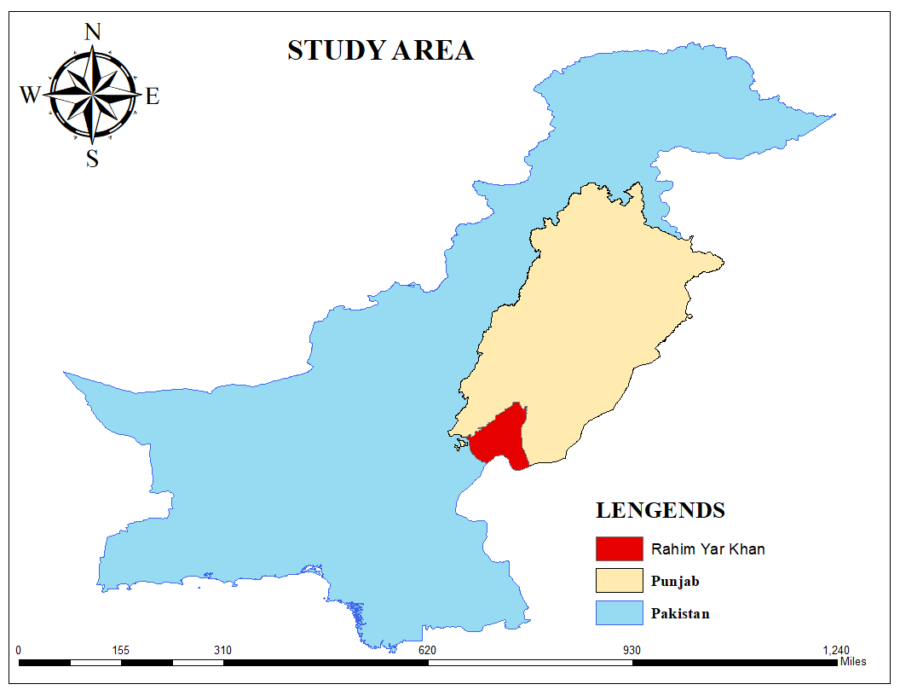

**Figure 1. Geographical Map of Study Area**

1. **Data Acquisition** 
   1. **Meteorological Data**

Meteorological data include precipitation, Tmax, Tmin, Relative humidity, Sunshine hours, and Wind speed data. The data will be gathered from the Pakistan Meteorological Department. The data from the observatories situated in Rahim Yar Khan, operated by the PMD, will be utilized.

* 1. **Agriculture Data**

Crop yield data for the last ten years will be obtained from the agricultural department of Punjab.

* 1. **Remote Sensing-Based Data**
* Landsat 8 satellite images for the last ten years will be downloaded and analyzed in GEE.
* Google Earth Engine is a cloud computing platform that offers extensive access to a massive archive of imagery of the satellite, including Landsat data. It also allows you to process and analyze the data directly in the cloud.
  1. **Field-Based Data**

Training points are chosen, and data on crop sowing history will be collected for crop classifications using a field-based survey**.**

**Table 1. Description of Various Data Sources**

|  |  |
| --- | --- |
| Data | Sources |
| Metrological Data  Temperature, Wind Speed, Relative Humidity | PMD, NASA POWER |
| Satellite Data | Landsat 8  (TIRS/OLI Sensors) |
| Crops Yield data | Agricultural Department |

**Objective 1: (Methodology)**

**SEBAL Model**

In this objective, the SEBAL will be employed to compute evapotranspiration (ET) in the study area using an imagery of Landsat satellite. These images will be acquired using onboard sensors capable of detecting signals across multiple ranges such as near-infrared, visible, and thermal wavelengths. Table 2 provides details of the Landsat 8 satellite, 11 bands including their wavelengths and spatial resolution. Figure 2 illustrates the key components of the SEBAL algorithm. The algorithm will calculate evapotranspiration values for each pixel during the satellite's transit time. The energy balance equation will be utilized to determine the level of evapotranspiration by using Eq. (1) (Allen *et al.*, 1998). Additionally, the net radiation (Rn) for each pixel will be computed using Eq. (2).

$$λET = Rn – G – H (1)$$

**Rn = RS↓ (1 − α) + RL↓ − RL↓ − RL↑ (1 − ℇ0) (2)**

**Table 2. Landsat8 satellite characteristics (Oguz, 2016)**

|  |  |  |  |
| --- | --- | --- | --- |
| Band Number | Bandwidth (μm) | Description | Resolution (m) |
| Band 1 | 0.435 – 0.451 | Coastal/Aerosol | 30 |
| Band 2 | 0.452 – 0.512 | Blue | 30 |
| Band 3 | 0.533 – 0.590 | Green | 30 |
| Band 4 | 0.636 – 0.673 | Red | 30 |
| Band 5 | 0.851 – 0.879 | NIR | 30 |
| Band 6 | 1.566 – 1.651 | SWIR-1 | 30 |
| Band 7 | 2.107 – 2.294 | SWIR-2 | 30 |
| Band 8 | 0.503 – 0.676 | Pan | 30 |
| Band 9 | 1.363 – 1.384 | Cirrus | 30 |
| Band 10 | 10.60 – 11.19 | TIR-1 | 100 |
| Band 11 | 11.50 – 12.51 | TIR-2 | 100 |

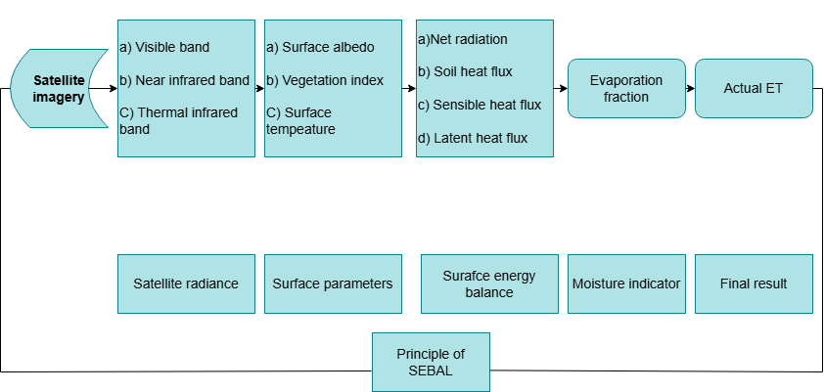**Figure 2. Principal components of the Surface Energy Balance Algorithm for Land**

Hence **λET** represents the latent heat W/m2; **Rn** depicts the net radiation flux W/m2; **G** is the soil heat flux W/m2; and **H** is considered as the sensible heat W/m2 and in Eq. (2) α represents the surface albedo (dimensionless); **RS** shows the incoming short-wave radiation; **RL↓** is incoming longwave radiation **RL↑**knows as the outgoing long waver radiation, and **ℇ0** is the broadband surface emissivity (dimensionless quantity) (Sun *et al.*, 2011).

These radiant fluxes will be estimated as depicted in Equations (3) to (5):

**RS↓ = Gsc. Cos θ. ꭇ. τsw (3)**

**RL↓ = ℇα. T4α. σ. (4)**

**RL↑ = ℇ0. T4S. σ. (5)**

**Gsc**is known as the constant of solar (1367 W/m2), **Cos θ** is the cosine of solar incidence angle, **r represents** Earth-Sun span, & **τsw**depicts the atmospheric transmissivity. **RS↓** The values may vary between two hundred and one thousand W.m-2, based on the location and the time of the image and resident climatic conditions. **σ** is the Stefan-Boltzmann constant (5.67*10-8 W.m-2.K-4), **Ts** represents the surface temperature (K), **ℇα** will be estimated using data from the alfalfa field in Idaho(6): (Bastiaanssen, 1995)

**ℇα = (-Ln τsw)0.09 * 0.85(6)**

**τsw** shows the atmospheric transmissivity computed assuming a clear sky and relatively dry conditions. It will be estimated by the relationship based on elevation of (Allen *et al.*, 2002). The rate at which heat is stored in the soil and vegetation as a result of conduction is known as soil heating (G). The following empirical equation will be used to calculate the G/Rn ratio (7): (Bastiaanssen, 2000).

$\frac{G}{Rn}=\frac{(Ts-273.15)}{α(0.0038α+0.0074α2)(1-0.98NDVI4)}$**(7)**

In this context, Ts represents the surface temperature (C), α shows the surface albedo and the Normalized Difference Vegetation Index ranges from -1 to +1. NDVI values among 0 in addition to approximately 0.2 typically indicate bare soil, while NDVI values higher than 0.2 correspond to vegetated areas. If the NDVI value is less than zero, the surface is considered to be water, and the ratio of soil heat flux to net radiation G/ is set to 0.5. For regions where the surface temperature Ts is below 4°C and the albedo α exceeds 0.45, the surface is supposed to be snow-covered, and G/Rn is also set to 0.5. The NDVI will be estimated using Equation (8):

**NDVI = $\frac{Near Infrared-Red}{Near Infrared+Red}$ (8)**

H is the rate at which hotness is transferred to air through conduction and flow processes (Morse *et al.*, 2000).

H will be computed from the Equation (9):

$\frac{ρ.Cp\left(Ts-Tr\right)}{rα}$**(9)**

In this equation, **ρ** shows the air density (kg/m3), **Cp** represents the specific heat of air at constant pressure (1004 J.kg -1K-1), **Ts** is considered as the surface temperature (K), **Tr** depicts the air temperature at a reference level (K). The term **rα** denotes the aerodynamic resistance to heat transport (s/m) (Allen *et al.*, 2002). The value of **rα** will be computed using Equation (10):

**rα = 1/(CH|V| (10)**

where **CH** shows the convective heat transfer coefficient, and **V** represents the wind speed at the reference level. (Tasumi *et al.*, 2003). The term **ETinst** (J/kg) is the ratio of instantaneous ET to the latent heat of vaporization (J/kg) (Equation (11)):

$ETinst = 3600 \frac{λET}{λ }$**(11)**

In this equation, 3600 converts seconds to hours and λ will be acquired according to Equation (12):

**λ = 2.501 - (Tα – 273) × 0.002361 (12)**

In this equation, **Tα** shows the atmospheric temperature (K), The **ET24** (actual daily ET estimation) (mm/day) is more effective than **ETinst.** SEBAL will estimate **ET24** assuming that the **ETrF** is a 24-hour average (fixed over 24 h), according to (13):

**ET24 = ETrF × ETr-24.  (13)**

In this equation, **ETr-24**. represent the twenty-four-hour**, ETr** is the day at which the image will be apprehended; **ETr** will be computed as the collection of hourly **ETr** readings for the day (Allen *et al.*, 2002).

**Objective 2: (Methodology)**

* WUE will be calculated to divide the crop yield with the evapotranspiration**:**

**WUE = $\frac{Crop yield (\frac{kg}{ha})}{ET (mm)}$**

* WUE will be evaluated for major crops in both regions, and comparisons will be made to identify trends and influencing factors.

**Validation**

SEBAL-derived ET estimates will be validated using meteorological data and the FAO Penman-Monteith approach:

* Daily meteorological data (solar radiation, temperature, wind speed, humidity) will be used to estimate ET₀ using the FAO Penman-Monteith model.
* SEBAL-derived ET values will be compared with ET₀ to assess accuracy and reliability.

Statistical indicators such as **Mean Absolute Error, Root Mean Square Error**, and **correlation coefficient** will be used for validation.

**VIII. References**

Allen, R., A. Morse, M. Tasumi, W. Bastiaanssen, W. Kramber and H. Anderson. 2001. Evapotranspiration from Landsat (SEBAL) for water rights management and compliance with multi-state water compacts. In: IGARSS 2001. Scanning the Present and Resolving the Future. Proceedings. IEEE 2001 International Geoscience and Remote Sensing Symposium (Cat. No. 01CH37217). p 830-833.

Allen, R., M. Tasumi, R. Trezza, R. Waters and W. Bastiaanssen. 2002. SEBAL (surface energy balance algorithms for land). Advance Training and Users Manual–Idaho Implementation, version 1:97.

Allen, R.G., M. Tasumi and R. Trezza. 2007. Satellite-based energy balance for mapping evapotranspiration with internalized calibration (METRIC)—Model. Journal of Irrigation and Drainage Engineering 133:380-394.

Allen, R.G., W. Bastiaanssen, M. Tasumi and A. Morse. 1998. Evapotranspiration on the watershed scale using the SEBAL model and Landsat images. In: 2001 ASAE Annual Meeting. p 1.

Bala, A., K.S. Rawat, A.K. Misra and A. Srivastava. 2016. Assessment and validation of evapotranspiration using SEBAL algorithm and Lysimeter data of IARI agricultural farm, India. Geocarto International 31:739 - 764.

Bukhari, S.R.H., A.U. Khan and S. Noreen. 2024. Optimizing Water Resource Governance for Sustainable Agricultural and Hydroelectric Development in Pakistan: An In-Depth Examination and Policy Prescriptions. Journal of Development and Social Sciences 5:280-293.

Bastiaanssen, W. 1995. Regionalization of surface flux densities and moisture indicators in composite terrain. A remote sensing approach under clear skies in Mediterranean climates 271.

Bastiaanssen, W.G.M. 2000. SEBAL-based sensible and latent heat fluxes in the irrigated Gediz Basin, Turkey. Journal of Hydrology 229:87-100.

Bastiaanssen, W.G.M., E.J.M. Noordman, H. Pelgrum, G. Davids, B.P. Thoreson and R.G. Allen. 2005. SEBAL model with remotely sensed data to improve water-resources management under actual field conditions. Journal of Irrigation and Drainage Engineering 131:85-93.

Bastiaanssen, W.G.M., M. Menenti, R.A. Feddes and A.A.M. Holtslag. 1998. A remote sensing surface energy balance algorithm for land (SEBAL). 1. Formulation. Journal of Hydrology 212-213:198-212.

Gao, Y., D. Long and Z.L. Li. 2008. Estimation of daily actual evapotranspiration from remotely sensed data under complex terrain over the upper Chao River basin in North China. International Journal of Remote Sensing 29:3295-3315.

Hatfield, J.L. and C. Dold. 2019. Water-Use Efficiency: Advances and Challenges in a Changing Climate. Frontiers in Plant Science 10.

Jaafar, H.H. and F.A. Ahmad. 2020. Time series trends of Landsat-based ET using automated calibration in METRIC and SEBAL: The Bekaa Valley, Lebanon. Remote Sensing of Environment 238:111034.

Jabeen, M., S.R. Ahmed and M. Ahmed. 2021. Enhancing water use efficiency and grain yield of wheat by optimizing irrigation supply in arid and semi-arid regions of Pakistan. Saudi Journal of Biological Sciences 29:878 - 885.

Kumar, A. 2024. Evapotranspiration: A comprehensive review. International Journal of Agricultural Sciences.

Khero, Z., P. Khahro and N. Samejo. 2020. Infrastructure Development in Closed River Basin: Impact Assessment Analysis on Lower Indus Basin.

Laghari, A.N., D. Vanham and W. Rauch. 2012. The Indus Basin in the framework of current and future water resources management. Hydrology and Earth System Sciences 16:1063-1083.

Morison, J.I.L., N.R. Baker, P.M. Mullineaux and W.J. Davies. 2008. Improving water use in crop production. Philosophical Transactions of the Royal Society B: Biological Sciences 363:639-658.

Morse, A., R. Allen, M. Tasumi, W. Kramber, R. Trezza and J. Wright. 2000. Final Report: Application of the SEBAL Methodology for Estimating Evapotranspiration and Consumptive Use of Water through Remote Sensing. Idaho Department of Water Resources, University of Idaho, Department of Biological and Agricultural: Moscow, ID, USA 107.

Muzammil, M., A. Zahid and L. Breuer. 2020. Water Resources Management Strategies for Irrigated Agriculture in the Indus Basin of Pakistan. Water 12:14-29.

Oguz, H. 2016. Calculating Actual Evapotranspiration in Adana, Turkey using Landsat 8 Imagery with the METRIC Model. In Proceedings of the 1st International Symposium of Forest Engineering and Technologies, Bursa, Turkey, 2–4 June 2016.

Qureshi, A.S. 2011. Water Management in the Indus Basin in Pakistan: Challenges and Opportunities. Mountain Research and Development 31: 375–388.

Rehman, A. 2016. Agricultural and Economic Development in Pakistan and its Comparison with China, India, Japan, Russia and Bangladesh. Andamios 13.

Rollason, R., T. Green and B. Bhattarai. 2023. Elevating river basin governance and cooperation in the HKH region: Summary report III, Indus River Basin.

Sun, Z., B. Wei, W. Su, W. Shen, C. Wang, D. You and Z. Liu. 2011. Evapotranspiration estimation based on the SEBAL model in the Nansi Lake Wetland of China. Mathematical and Computer Modelling 54:1086-1092.

Tasumi, M., R. Trezza, R.G. and Allen and J.L. Wright. 2003. US Validation tests on the SEBAL model for evapotranspiration via satellite. In: ICID Workshop on Remote Sensing of ET for Large Regions, Montpellier, France. 14: 54-68.

Ul-Allah, S., A.A. Khan, T. Fricke, A. Buerkert and M. Wachendorf. 2015. Effect of Fertiliser And Irrigation on Forage Yield and Irrigation Water Use Efficiency in Semi-Arid Regions of Pakistan. Experimental Agriculture 51:485-500.